Name: Mohamed Mamdouh Refaiy Abdelaziz

Sec : 37

Group : 7

### My Github:

Topic : Artificial Intelligence

## Application Brief:

It is clear how amazing this field ,So it is important to talk about this topic which is useful to our life.

As we should depend on this field in learning so that we could develop our education.

## ScreenShots:

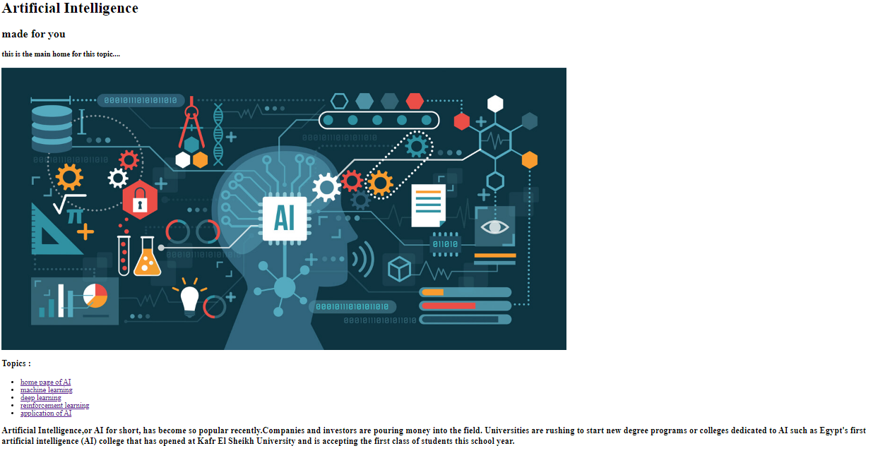

## 

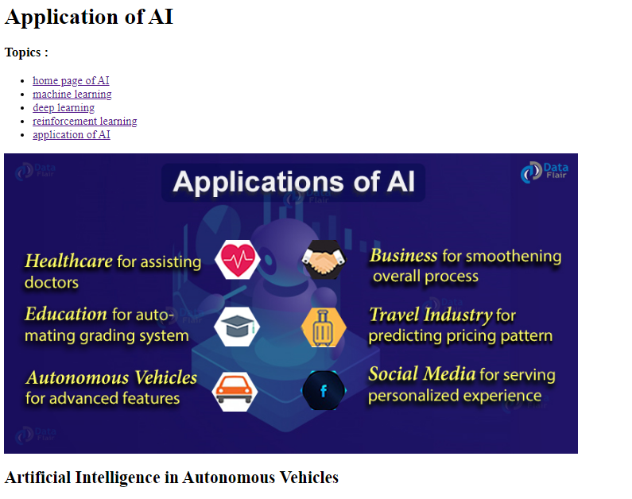

Source Code:

